John Wetters

Two element matching program demo

Objective
Document the Matlab two element matching program two_element_matching.m. Show the utility of Matlab complex number calculations are for complex impedances. Show how to plot a Smith chart in Matlab. Show how to perform a 2 element match to 50 ohms termination using the Smith chart. Show that depending on the termination impedance that there is more than one combination of elements solving the problem.

Matlab Smith Chart plot
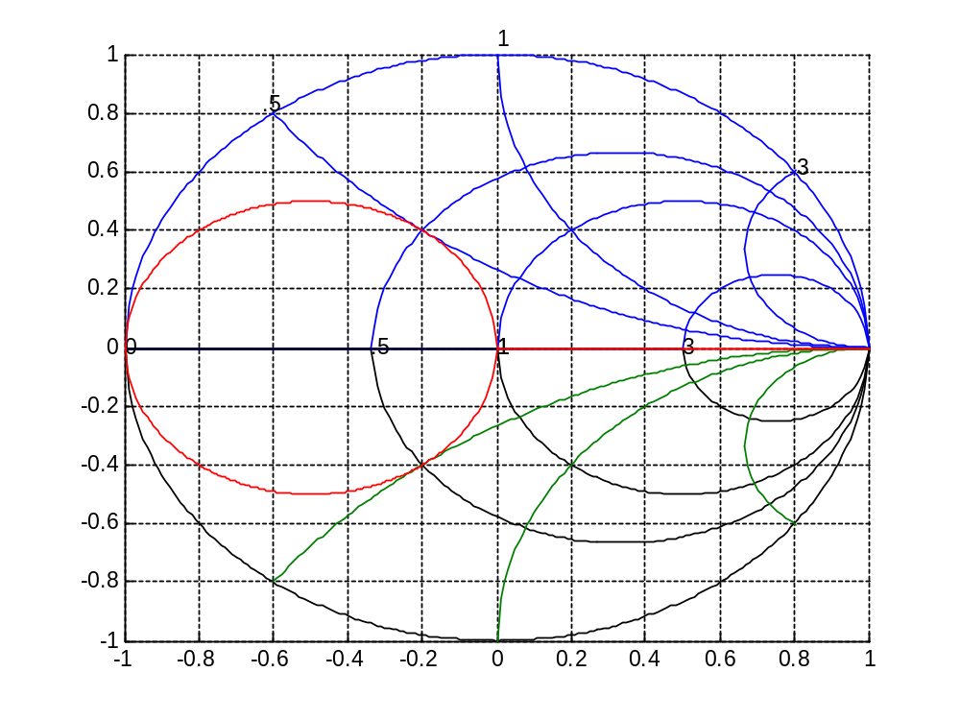
Figure 1 – Matlab normalized smith chart plot

By typing “smith3” the Smith chart plot shown in Figure 1 appears in a Matlab figure. The Smith chart will be used to solve the two element matching problems.

Test problem
First, we are going to test the program by solving for a termination of a normalized real impedance of .1 and a normalized imaginary impedance of .6 at 150MHz. The normalized impedance is defined as the complex impedance Z divided by the characteristic impedance of the network.
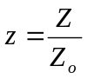

Our example of .1+j.6 in a 50 ohm system is 5+j30 ohms. The complex number operator used is 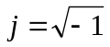to keep consistent with electronics literature in this area. Since Matlab was written by a mathematician it normally uses as the complex operator, but it still represents the same mathematical properties of the used in electronics literature. To let Matlab know what you want j as the complex number operator just add the code j=sqrt(-1) and Matlab will then know you mean the complex number operator for j.

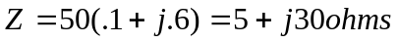

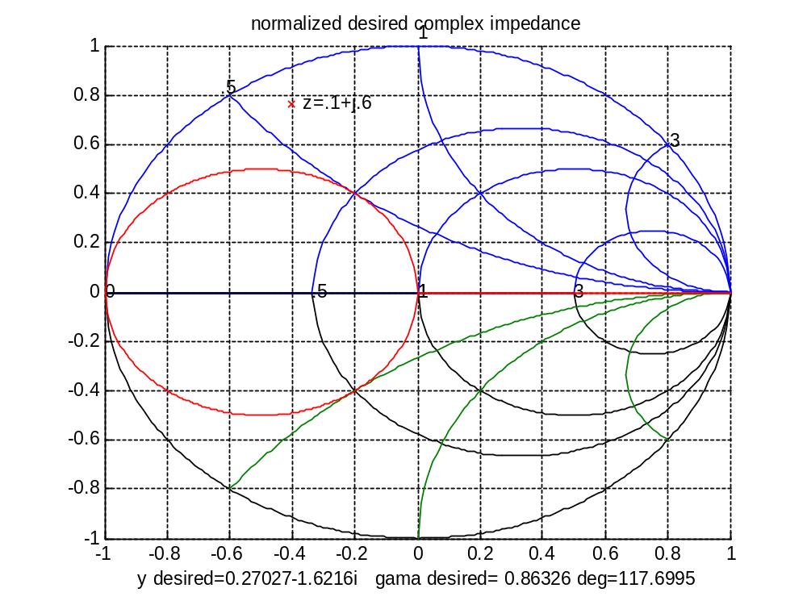
1+j0=50 ohms
.1+j*.6 =desired impedance
1+/-js
admittance
circle
1+/-jx impedance
circle
Figure 2 - Smith chart plot of desired reflection coefficient, gama

Figure 2 shows the plot of the desired reflection coefficient, gama . Code listing 1 (from two_element_matching) shows the code to plot gama. Smith 3 is a function call to plot the Smith Chart. Notice that gama as plotted on the smith chart is calculated from the desired complex impedance by:
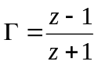

where z is the normalized complex impedance. This is where the built in complex number capability of Matlab helps the calculations. The statements in code listing 1 show how the desired reflection coefficient is plotted on the Matlab smith chart figure. z1 is the real part of the desired reflection coefficient (.1) and z2 is the imaginary part of the desired reflection coefficient (.6).

zcomplex=z1+j*z2 %this is the needed impedance
gama=(zcomplex-1)/(zcomplex+1)
figure(1)
smith3
plot(gama,'rx')
title('desired gama')
s3=[' z=' s1 '+j' s2]
text(real(gama),imag(gama),s3)
code listing 1 –Plotting the desired reflection coefficient

Looking at Figure 2, there are 4 possible ways to start at 1+j0 and arrive at the desired impedance of .1+j.5. We can either use the 1+/-js admittance circle by adding a shunt capacitor (C), or shunt inductor (L) or we can follow the 1+/-jx reactance circle by adding a series inductor or series capacitor.

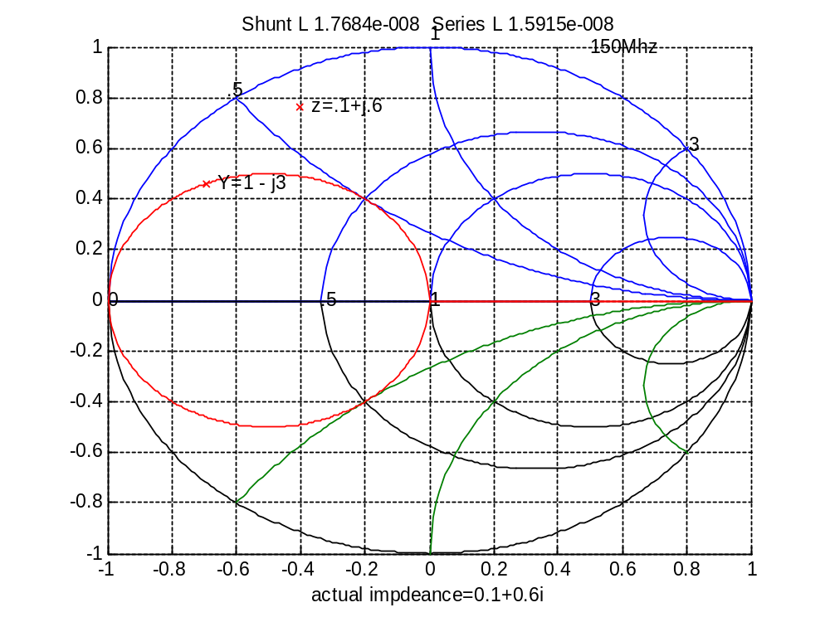
Shunt L=17.7nH
Series L=15.9nH
Figure 3 - shunt L series L match

The first solution we will address is a shunt L series L match and shunt C series L. Looking at Figure 3 we start at the 50 ohm 1+j0 point at the center of the Smith chart. Since we are doing a shunt elements, we proceed on the y=1+/-js circle to the intersection of the real(z)=.1 radius where y is the complex admittance and “s” is the imaginary part of the complex admittance (susceptance).

We can derive the equations used in the program. Let z1 be the real part of the desired impedance z, therefore:

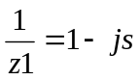

In other words, find the intersection of the real part of the desired impedance with the 1+/-js admittance circle on the Smith chart. Multiply both sides of the equation by (1+js).

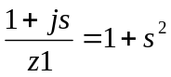

Solve for “s” using the real parts of the equation.

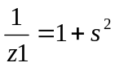
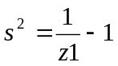
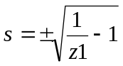

Substituting in .1 ohms in for z1 we get:

s=+/-3

So there are 2 solutions or intercepts to the 1+/-js circle, yInterceptP, the positive intercept (1+j3) and yInterceptM, the negative intercept (1-j3). The positive intercept corresponds to the shunt capacitor (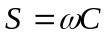). The negative intercept corresponds to a shunt inductor (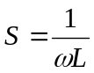).
From the Y intercepts on the 1+j0 admittance circle, we can calculate how much impedance is needed for the desired impedance from the 2, y intercept points. This will rotate the intercept point from the 1+/-js circle to the desired impedance point (z1+jz2). As shown in code listing 2 deltaZP is the impedance to rotate to the desired impedance from the positive intercept and deltaZM is the impedance to rotate to the desired impedance from the negative intercept.

deltaZP=imag(zInterceptP)-z2
deltaZM=imag(zInterceptM)-z2
code listing 2 –finding the impedance to rotate to the desired impedance

Now that we have all the normalized impedances calculated, we can now calculate all the 2 element matches that solve the desired match.

First for the shunt L series L match:

If (deltaZP < 0 & imag(s)==0) % We want a Shunt L Series L match.

We need to check to make sure there is an intersection to the 1+js admittance circle by checking that the imaginary part of s is 0.

The shunt L is calculated from the admittance y at the intersection of the z=.1 radius.

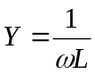
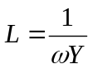

Since YL was a normalized impedance we have to multiply by 50 mhos since we are working in a 50 ohm system.

shuntL=Zo/(w*s)

The series L is calculated from the impedance to move from the intersection of the z=.1 radius to the desired impedance.

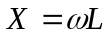

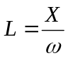

Since X is a normalized impedance we have to multiply by 50 ohms since we are working in a 50 ohm system.

seriesL=abs(deltaZP*Zo)/w

As shown in Figure 3, the answer is a shunt L of 17.7nH and a series L of 15.9nH.

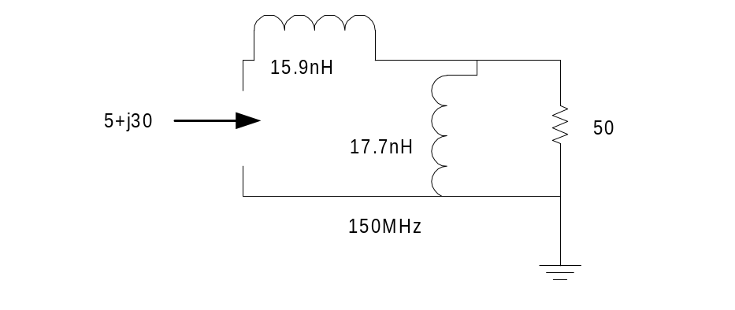

Figure 4 – Shunt L, Series L solution

For each two element solution we check that the normalized impedance is correct by calculating it independently with a two element function. The check is printed at the bottom of each figure with ”actual impedance is”.

%check solution
[zTest]=shuntL_seriesC(shuntL,seriesC,w,Zo)
xlabel(['actual impdeance=' num2str(zTest)])
code listing 3 - Check to se that normalized impedance is correct

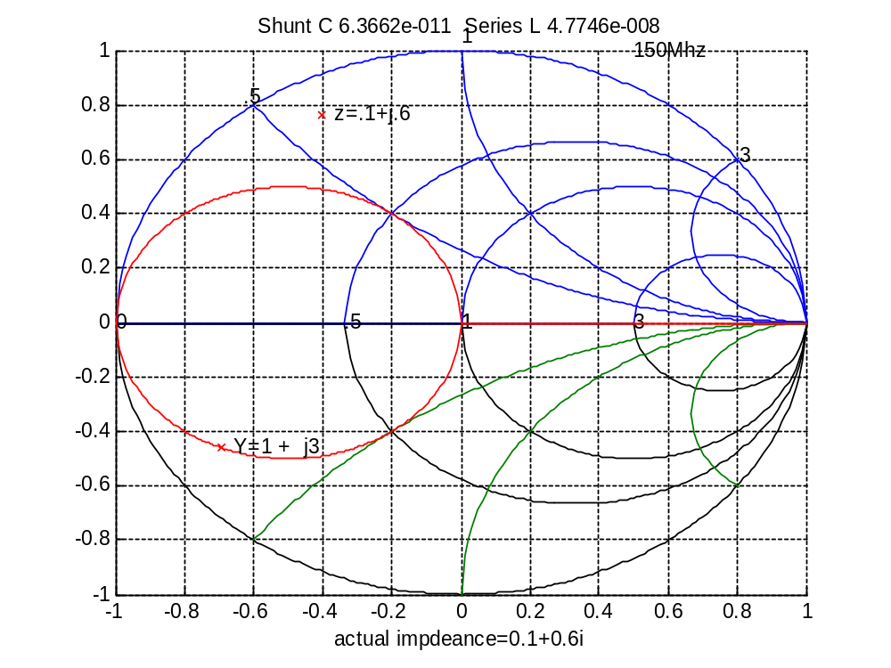
Shunt C=63.6pF
Series L=47.7nH
Figure 5 - shunt C series L match

We perform the same logic for the shunt C series L case below.

If (deltaZM < 0 & imag(s)==0) % We will need a Shunt C and Series L to match.

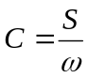

Since s was a normalized susceptance we have to divide by 50 mhos since we are working in a 50 ohm system.

shuntC=s/(Zo*w)

The shunt C calculated for our example is 64.7pF.

The series L is calculated from the impedance to move from the intersection of the z=.1 radius to the desired impedance.

Since X is a normalized impedance we have to multiply by 50 ohms since we are working in a 50 ohm system.

seriesL=abs(deltaZM*50)/w

The series L was calculated to be 47.7nH.

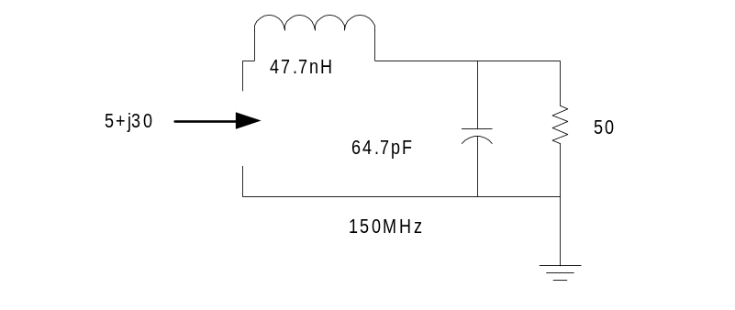
Figure 6 – Shunt C Series L network

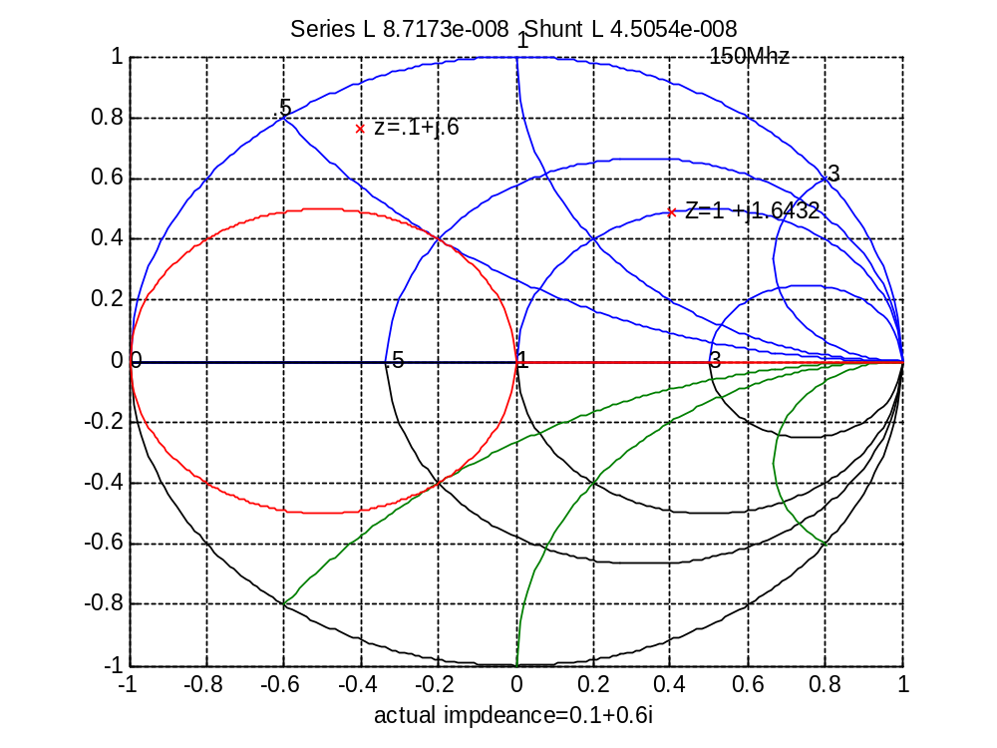
Shunt L=45.1nH
Series L=87.2nH
Figure 7 - series L shunt L match

Now that we have solved the 2 roots on the admittance circle of y=1+/-js we will look at the 2 roots on the 1+/-jx circle.

Looking at Figure 7 we start at the 50 ohm 1+j0 point at the center of the Smith chart. Since we are doing a series L shunt L match, we proceed on the z=1-jx circle to the intersection of the real(y)=.27 radius. Note that the wanted admittance y is .27-j1.62 which is the reciprocal of .1+j.6.

Let y1 be the real part of 1/z, therefore:

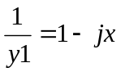
Multiply both sides by (1+jx) and solve for x.

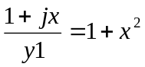

Solve for x only using the real parts of the equation.

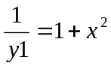
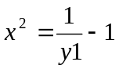
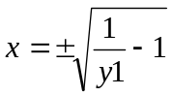

z=sqrt(1/real(ycomplex)-1)

Similar to the admittance intercepts, there are 2 intercepts on the z=1+jx circle. 1+/-j1.6432.

First we perform the series L shunt L match.

If (deltaYM > 0 & imag(z)==0) % we need a Series L Shunt L match.

Since x was a normalized impedance we have to multiply by 50 ohms since we are working in a 50 ohm system.

seriesL=abs(z*Zo)/w

The shunt L is calculated from the admittance to move from the intersection of the y=.2703 radius to the desired admittance.

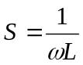

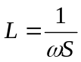

Since s is a normalized admittance we have to multiply by 50 mhos since we are working in a 50 ohm system.

shuntL=Zo/(abs(deltaYM)*w)

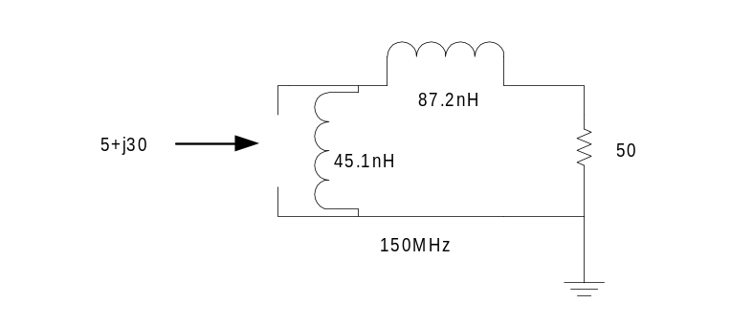
Figure 8 – series L and shunt L solution

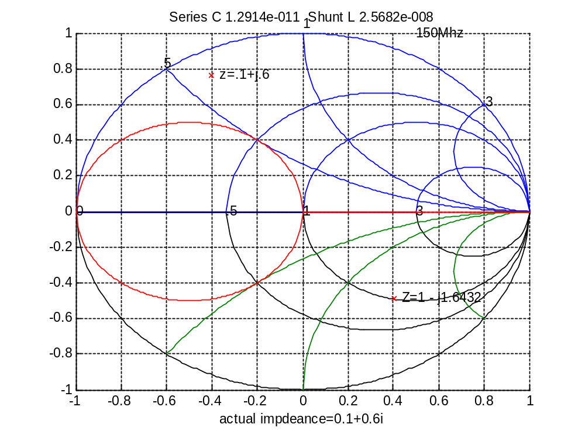
Shunt L=25.7nH
Series C=12.9pF
Figure 9 - series C shunt L match

The final combination is the series C shunt L match.

if (deltaYP > 0 & imag(z)==0) % We will need a Series C Shunt L to match.

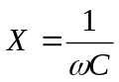

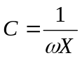

Since x was a normalized impedance we have to multiply the impedance x by 50 ohms since we are working in a 50 ohm system.

seriesC=1/(50*z*w)

The shunt L is calculated from the admittance to move from the intersection of the g=.2703 radius to the desired impedance.

Since s is a normalized admittance we have to multiply by 50 mhos since we are working in a 50 ohm system.

shuntL=50/(abs(deltaYP)*w)

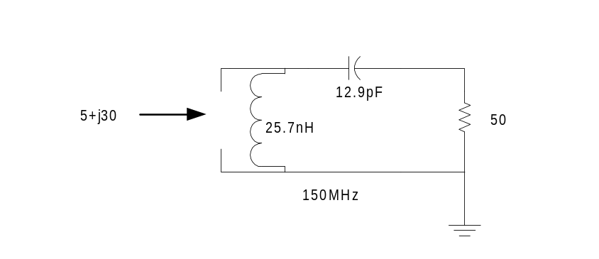
Figure 10 series C shunt L solution

